PROJECT 1

STEP 1: CREATE TWO BUCKETS.

1. Source Bucket 2.
2. Destination Bucket

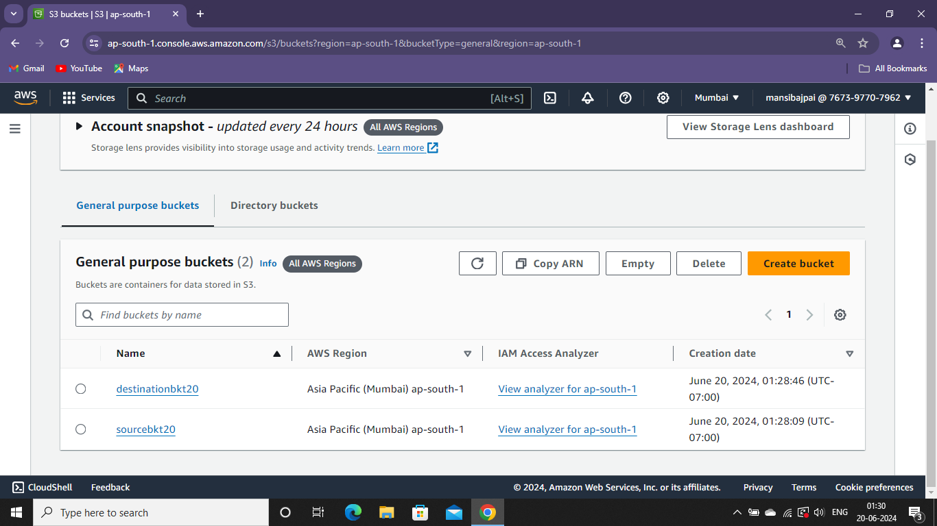

Upload the image in the source bucket.

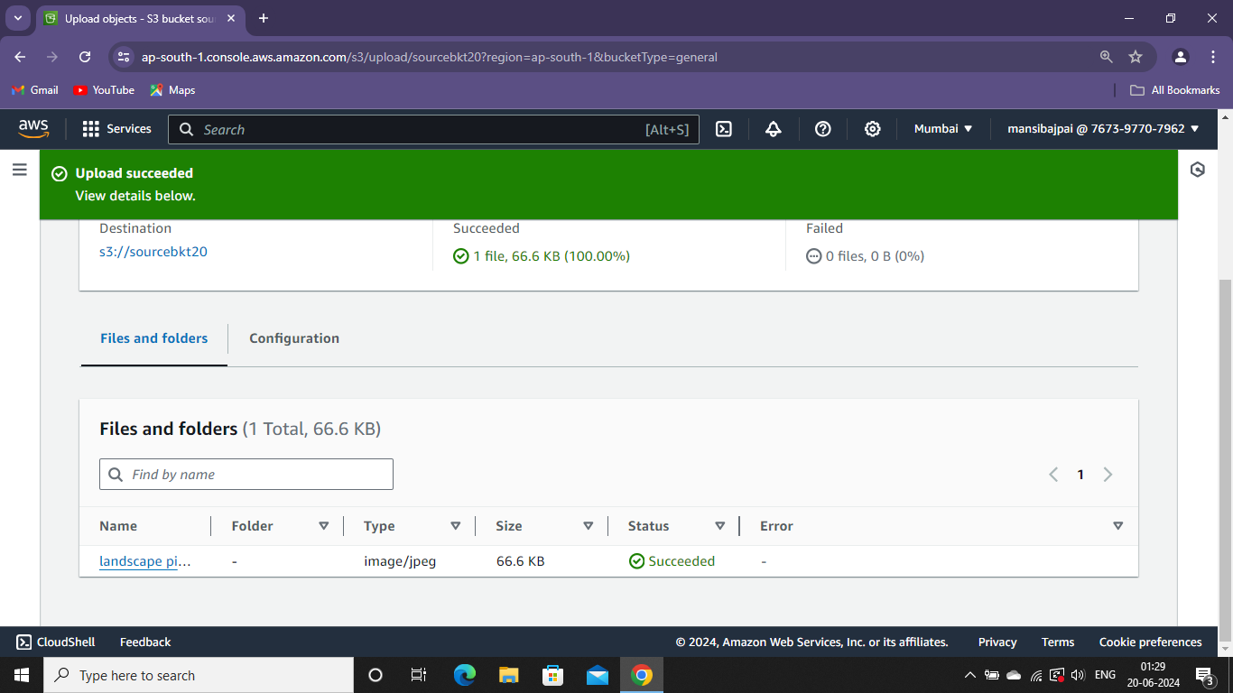

STEP 2: CREATE LAMBDA FUNCTION

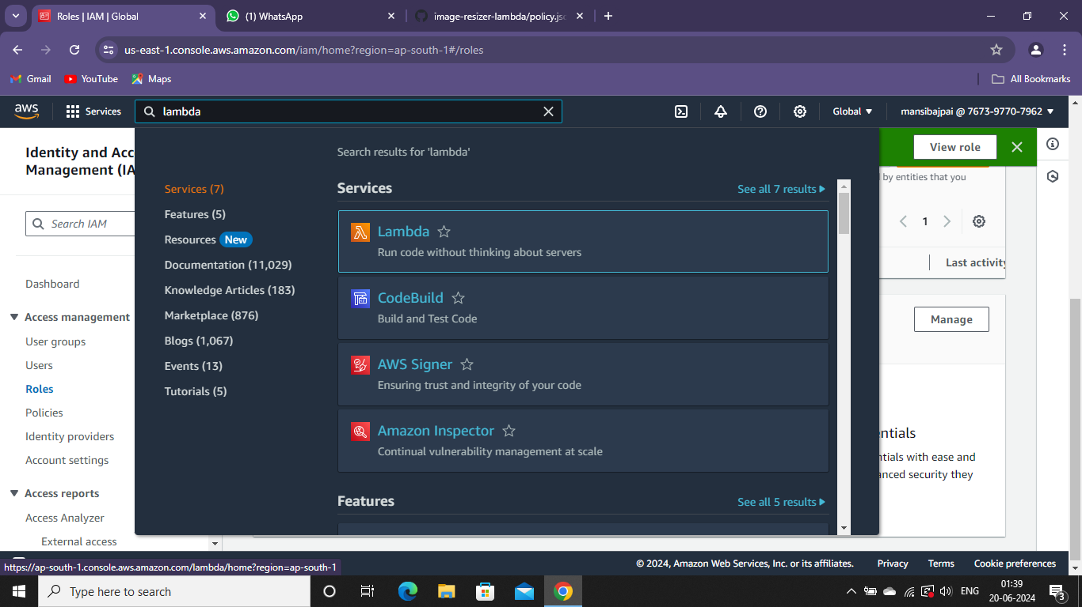

Option: author from scratch

Function Name : lambdafunction

Runtime: Node.js 18.x

Architecture: x86_64

Go to IAM console.

Search IAM

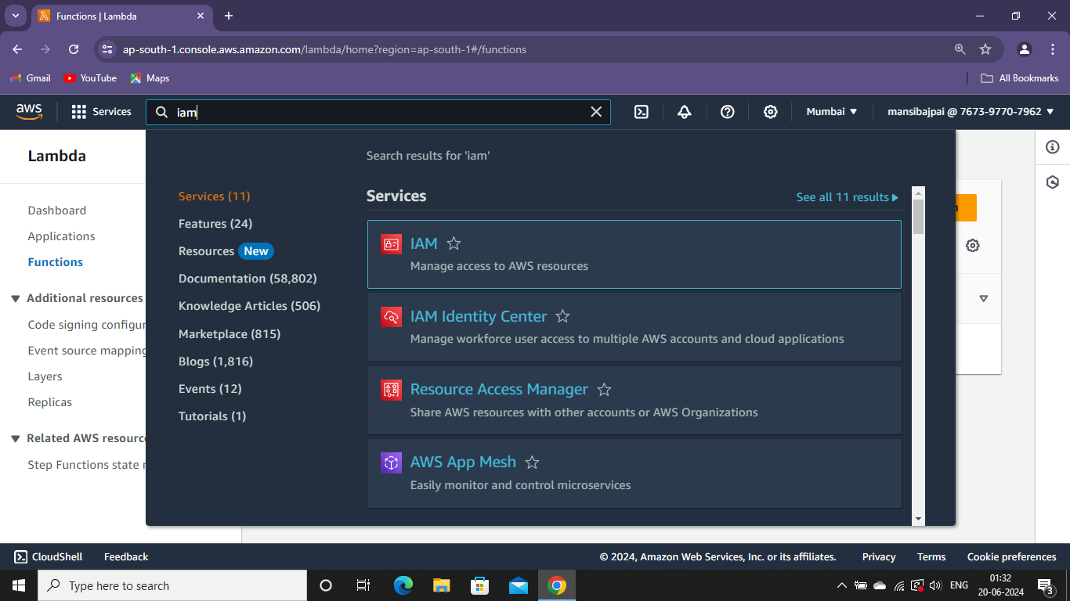

Then go to policies.

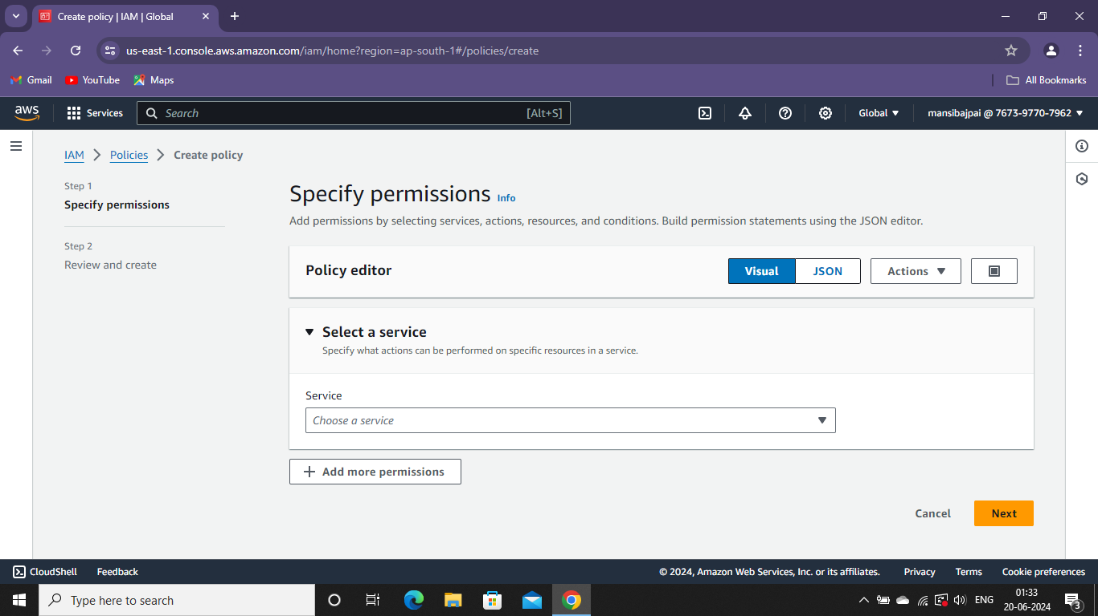

Click on JSON

And replace the original code with the new one that you have created

Edit the resources with the buckets you have created.

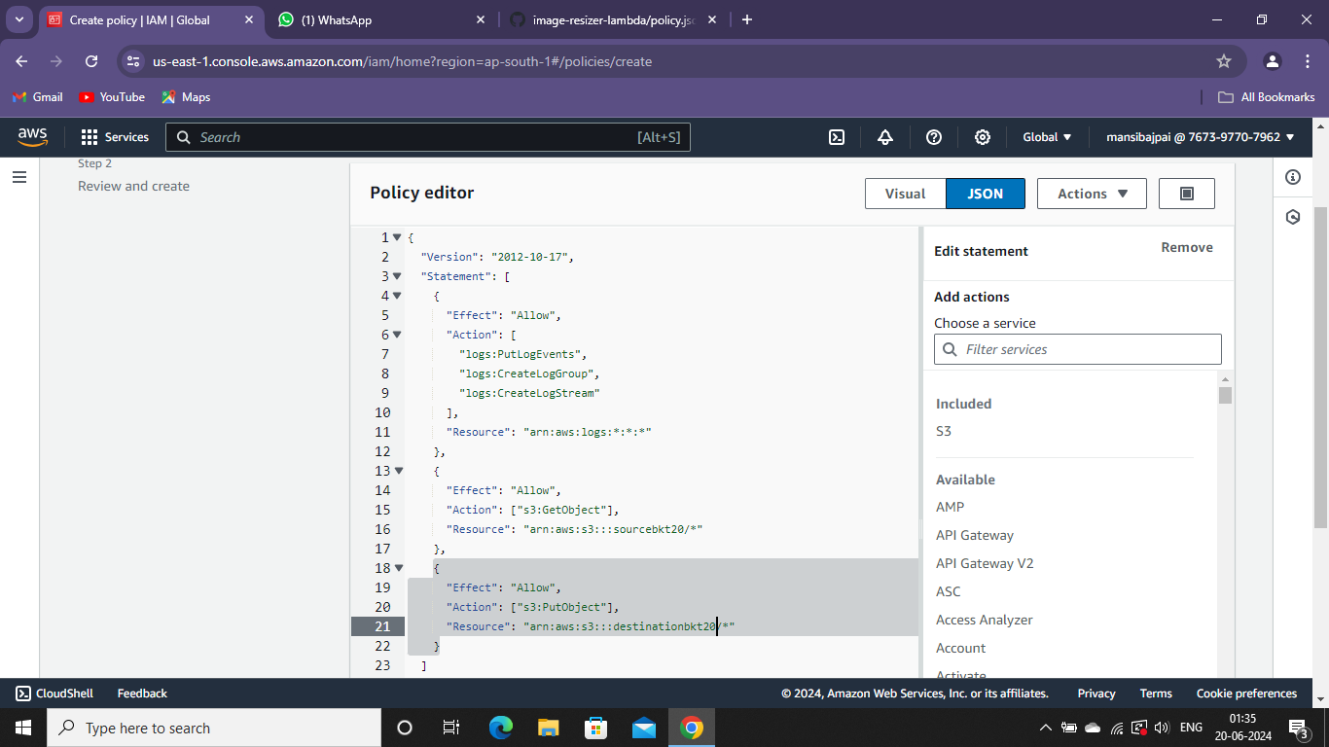

Policy details : .

policy name : lambdapolicy

Create role.

And choose case

: Lambda.

In add permissions search your policy that you have created.

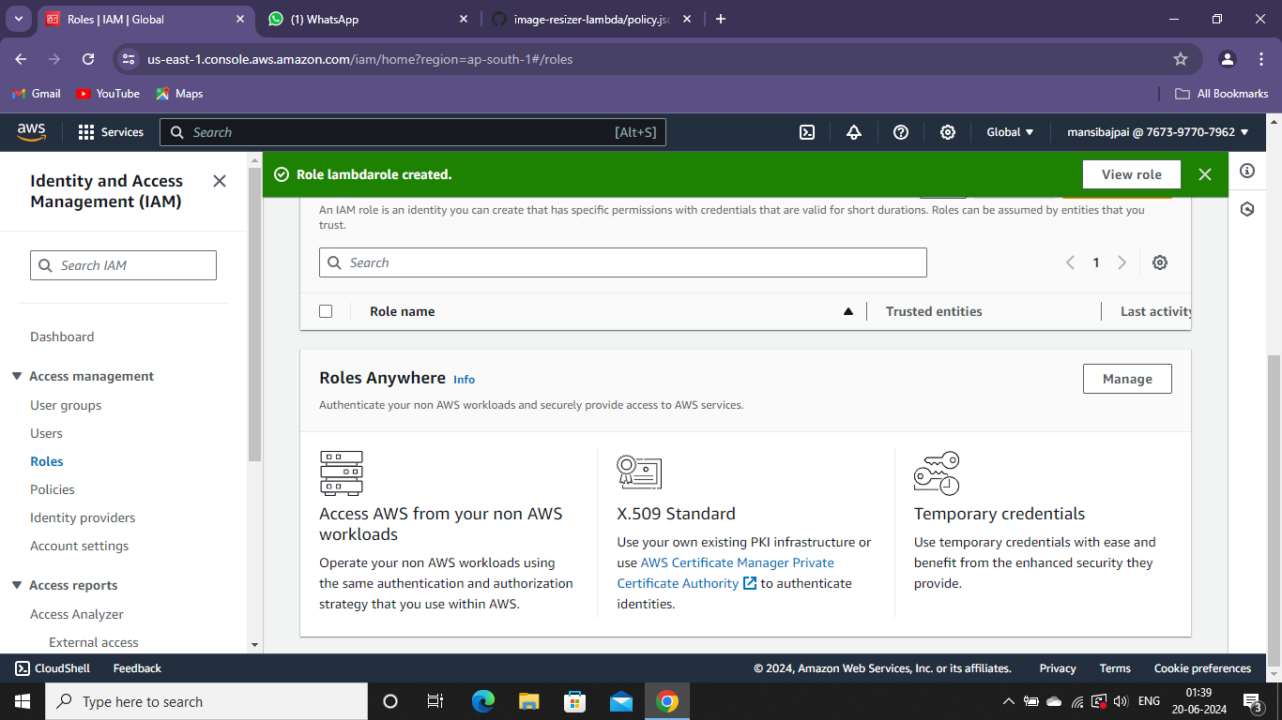

Create role. And choose case : Lambda. In add permissions search your policy that you have created.

Then go to add trigger.

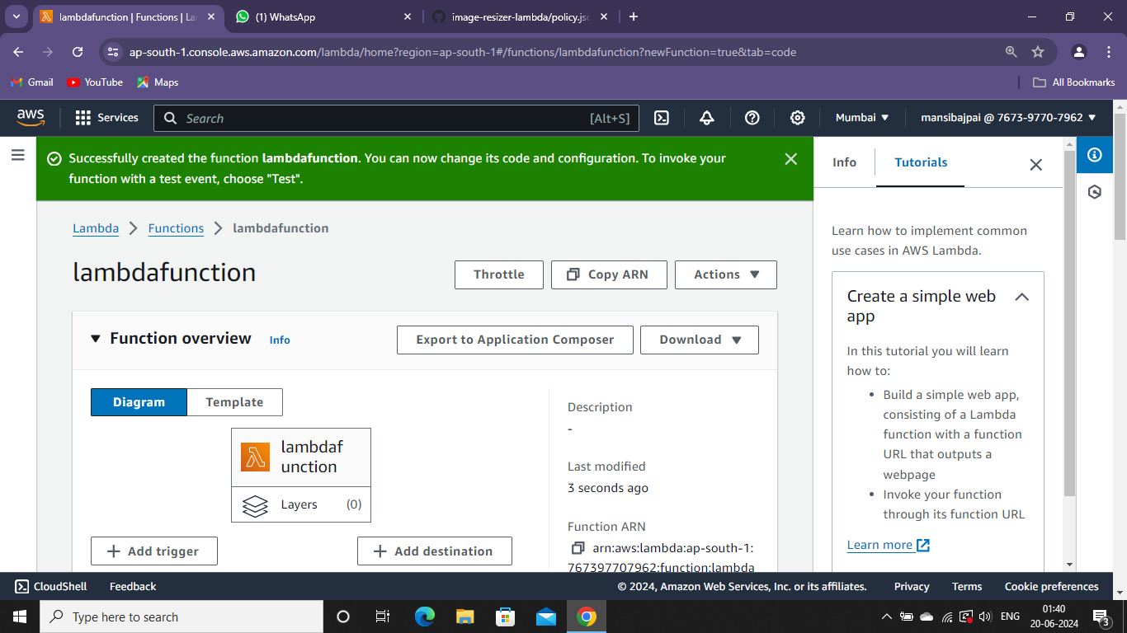

Then select the source : S3

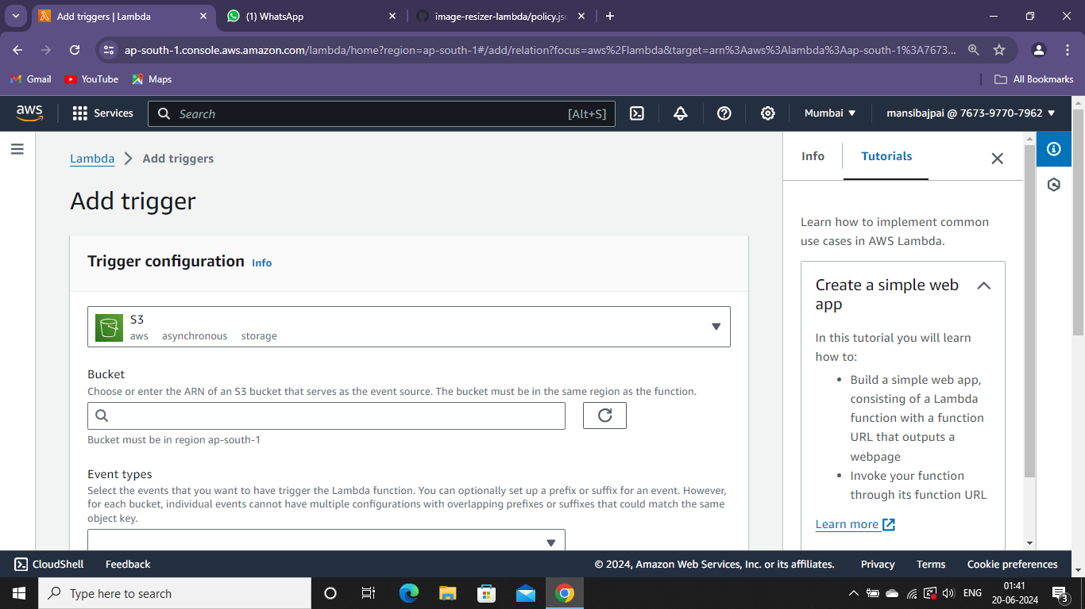

Select your source bucket.

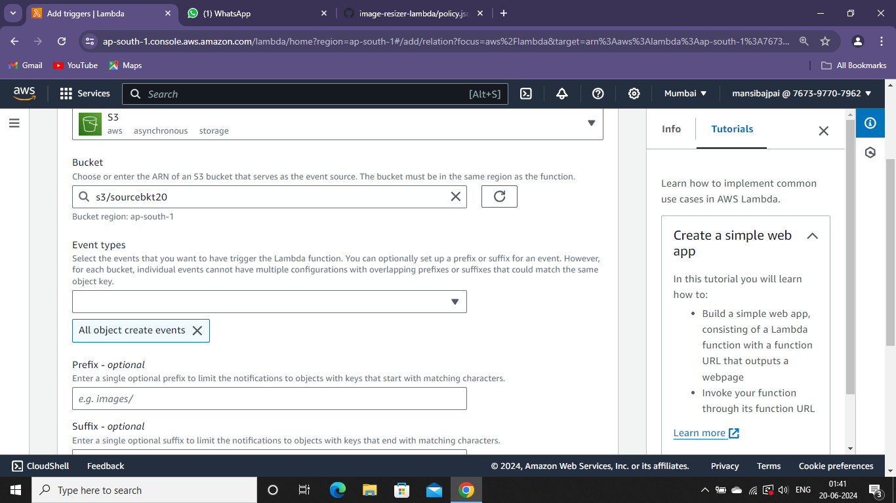

Then add.

Go to environmental variables.

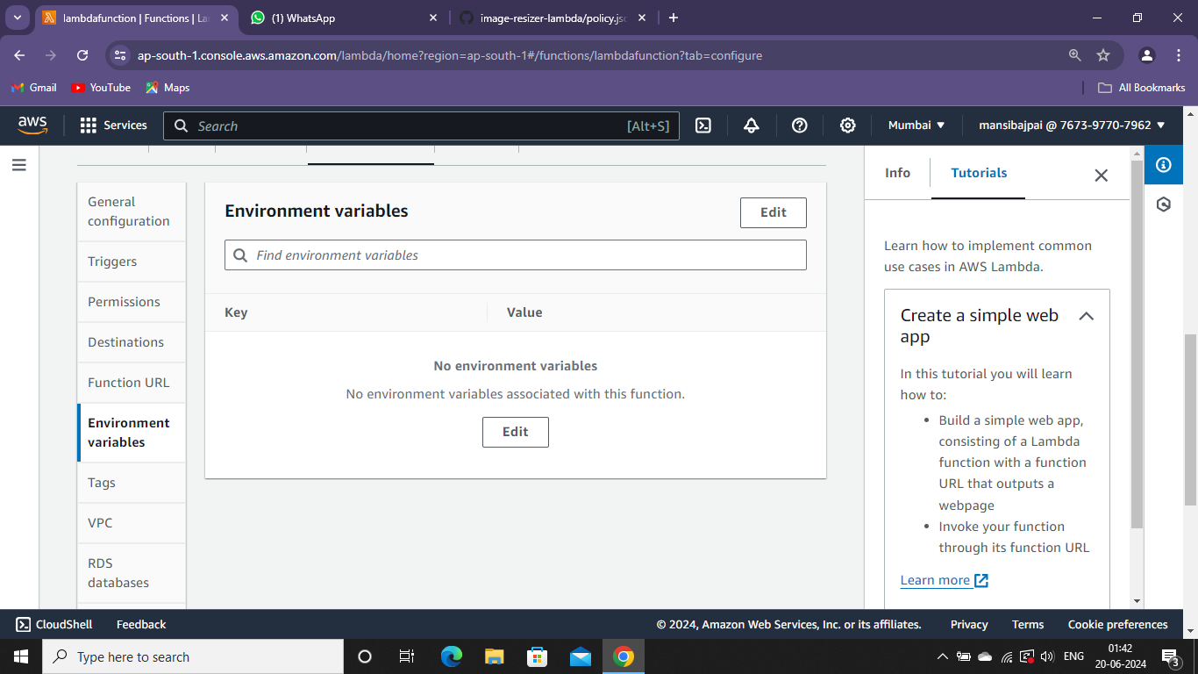

KEY: DEST_BUCKET

VALUE: destinationbkt20

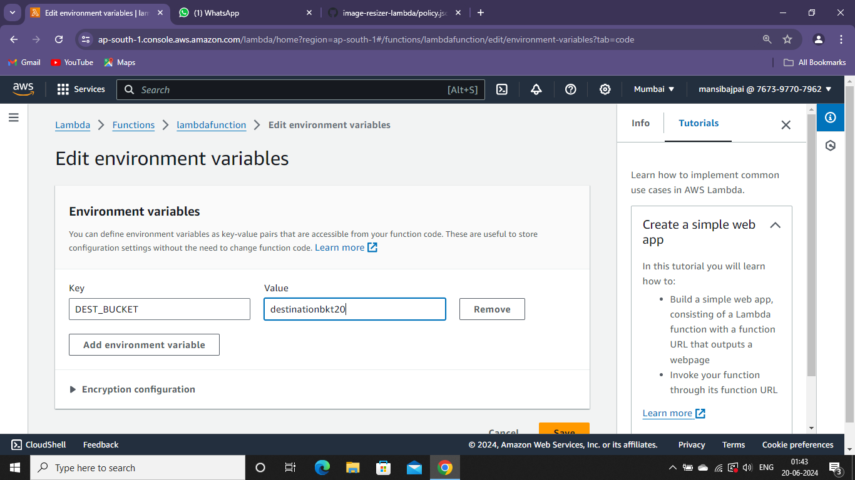

Go to code and upload your downloaded zip file.

